Remus Jackson
1/29/21

Spring 2021 Community Assignment Building Process

Table of Contents
Introduction 1
Ethos 2
Process 3
Outcomes 8
Considerations for future application 9

Introduction
The Spring 2021 semester loomed uncertainly above us as I tried to prepare my syllabus. The University of Florida’s mandate that we ‘return to normal’ through their misnamed ‘hyflex’ classes meant that I had to prepare to teach, potentially, in a modality I was ill-equipped for, under conditions that were changing so rapidly that trying to pin down a plan for the end of January, let alone sixteen weeks of a semester, seemed to me to be an exercise in absurdity.
My pedagogical practice, or how I orient myself as a teacher, draws on disability justice and liberatory pedagogy. Disability justice is a framework centering “the lives, needs, and organizing strategies of disabled queer and trans and/or Black and brown people marginalized from mainstream disability rights organizing’s white-dominated, single-issue focus” as well as the inaccessibility of disability studies in academia (Leah Lakshmi Piepzna-Samarasinha, Care Work, 15). In university pedagogy, a disability justice framework challenges the inherently ableist structures of higher education by empowering students to articulate their own accessibility needs and by designing classes to be accessible from the ground up, rather than waiting for a DRC letter to prove the need to make “adjustments.” Liberatory pedagogy is a critical educational practice centered on principles for social change, consciousness-raising and transformation through engagement with oppressive forces. In practice, this means making space for students to come to the table with their own voices and histories and facilitating their intellectual growth; it also means directly addressing issues of racial justice, trans and queer liberation, disability justice, and other movements for social change in the classroom.
Always, but especially now in the time of Zoom University, I work against notions of punishment and surveillance in teaching, particularly around grading and how we judge ‘participation’. The course I was set to teach was a special topics composition course centering on queer activism & art in response to the AIDS crisis. Because these special topics courses come with a bit more flexibility in the syllabus for lower division courses—I didn’t have a pre-existing curriculum to attend to, just the University’s word count policy—I decided that I’d embrace the uncertainty and the nature of the class and invite my students to collaborate with me on the creation of our assignments.
This packet documents my process throughout that collaboration: the ethos driving the idea, the steps I and my students took, and the outcome of our work. It also includes some considerations on how this process could be improved and/or adapted to other courses in the future.

Ethos
As mentioned, I draw on disability justice and liberatory pedagogy as the main frameworks for my pedagogy. Assignment design is a core part of that process: assignments are how we make space for students to practice the skills they’ve been building and think through the ideas they’ve been encountering. As a writing instructor, I am less interested in seeing my students hit a checklist I’ve designed of what a “good paper” is supposed to look like. Further, in my experience, students come to the writing classroom with a sense of what they’re “supposed” to learn, what they want to learn, and what they perceive their weakest points to be.
In previous semesters I have invited students in to the rubric-making process, both by collaboratively building rubrics based on what we collectively determine to be most important in assessing their work, and through conversations around the rubrics I’ve designed. This approach allows students to define for themselves what their goals are in learning writing; it also helps demystify the grading process, as I’ve found many students (including myself!) often feel grading is a punishment system rather than a way of offering feedback to help them grow.
Inviting students into the assignment building process seemed to be a natural extension of this horizontal learning work. After all, if students know what they want to learn, they also know how they learn—or at least have a sense of it. In the face of ‘hyflex’, the ongoing pandemic, and the United States’ political climate in 2020, leaning in to uncertainty, and offering the students an opportunity to be active designers of their own learning, felt especially important.
It also felt important to honor the nature of the class itself in this way. ACT UP’s structure, after all, was not hierarchal, but deliberately diffused across horizontal committees in the style of Spanish anarchism. I don’t want to overstate, or make collaborative assignment building seem more lofty than it is—but what I am hopefully conveying is that the subject of the course requires my students and myself to think about grassroots, collaborative action, and I wanted that spirit to be reflected in as much of the course design itself as I was able to.
To sum up the core ethos of my framework for collaborative assignment building:
- Students are able to identify what they want to learn and what skills they need to develop
- Students are more invested in the course/in their assignments when they understand how the design of the assignment helps them learn or grow their skills
- Flexibility, collaboration, and horizontal learning practices are always important, but especially important in this moment of great social upheaval and distress.
- Assignment design can, and should, also reflect the politics of the classroom.

Process
This course is a lower division general education composition course, which means the University has certain set requirements for it, specifically a 6,000 word count total. On my syllabus, where I first explained we would be building our major writing assignments together, I reflected this like so:
This is a 6,000 word writing class. The following is a suggested outline for how those words could be potentially broken down across the semester.

This semester is unprecedented for all of us. We’re not only still working in a pandemic, but we’re also entering into a new model of learning and teaching. To that end, we will develop together, in class, our major assignments for the semester, using this outline as a starting point.
Underneath this text, I provided a potential outline for major writing assignments that drew from how I’ve structured class assignments in previous semesters. I deliberately chose to set up two minor assignments, labeled “Journal” assignments: a set of short responses and a set of mind-maps that accounted for 2,750 of the 6,000 word total. This provided some structure for us to start with.
About a week prior to the first day of the semester, I sent out an introduction email, and included this message:
also, given the strangeness of the semester, i’m trying something new with our assignments. as we know, this is a 6,000 word class, but the form those 6,000 words can take is relatively open-ended—thus, we’re going to spend the first couple weeks designing our writing assignments together. so if you have the space for it, spend some time in the coming week thinking about 1) what kinds of writing skills you want to develop (analysis, research, close-reading, etc), 2) what kinds of writing assignments you’ve personally found helpful for you in the past, and 3) genuinely, where you’re at energy-wise and what will be the most sustainable while being helpful/instructional.

the syllabus offers a suggested outline for how those words might break down, but again, i want this to be an open conversation.
On the first day of the class, I went over this again and invited them to a collaborative Google Jamboard with three questions on it:
- What kinds of writing assignments are you most interested in? (long form essays, short form essays, blogposts, podcasts, creative assignments, etc)
- What writing skills do you want to practice? (e.g. research, grammar/sentence structure, organization, pre-writing, etc)
- What your ideal writing assignment would be
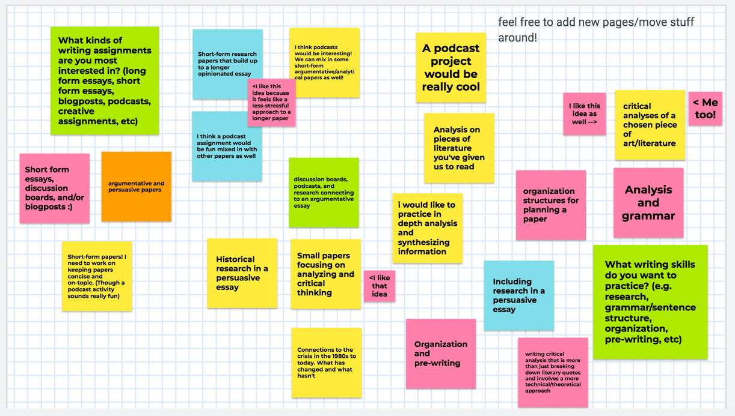
Figure 0-1. Google Jamboard showing digital post-it notes from students.

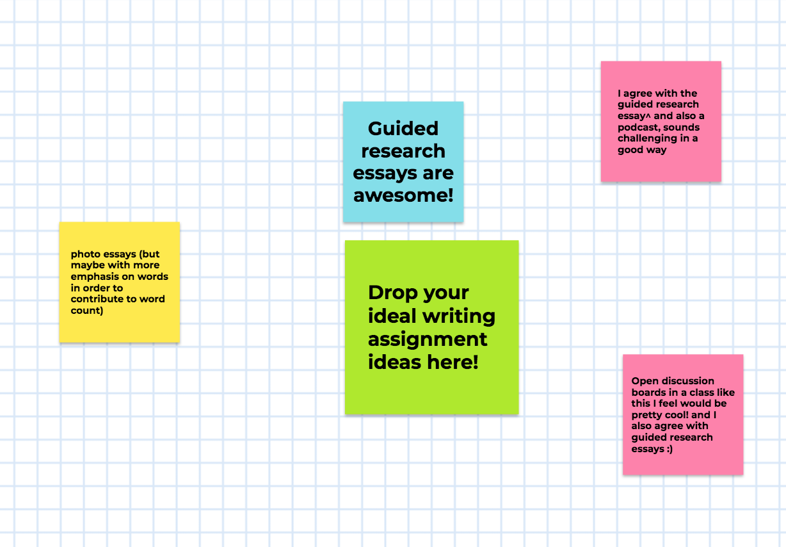
Figure 0-2. Google Jamboard showing digital post-it notes from students.

I took the information they provided in discussion and on the Jamboard and set up a Canvas discussion board that summarized what they’d written, and attempted to synthesize the skills & assignments they identified into a reasonable schedule of assignments:
hi all!
as we discussed in class, we'll be using this first week to brainstorm our major writing assignments for this class. my goals here are to prioritize + honor what you want to get out of this writing class.
we began with this google jamboard: https://jamboard.google.com/d/1jOR1DvEBQTUWFSXd6ybOoO30HKCHBhC7YQMFWCGnI6s/edit?usp=sharing (Links to an external site.)
which i'll briefly summarize here:
What kinds of writing assignments are you most interested in?
- Short form papers (5 suggestions for this!)
- Some sort of podcast/blogpost assignment
- Something that the smaller assignments build up to (a longer form paper or project of some kind)
Almost all of these suggestions emphasized 1) building research skills and 2) developing argumentative/analytical skills
What writing skills do you want to practice?
- Critical analysis of a particular art piece/literary work (this got some agreements!)
  - Analysis (understandably) came up a bunch here, especially "technical/theoretical" approaches
- Incorporating research
- Grammar and structure/organization
- Pre-writing (and how to plan for structure/organization)
for "Ideal assignment" ideas, a photo essay came up, a guided research essay, a podcast, and open discussion boards (good news, we're definitely doing this last one.)

From this - of course, it'd be impossible to come up with something that suits everyone, but I'm going to make a couple of suggestions as starting points and we can keep talking about it from there.

For this discussion - let's think about what approach(es) we like/want to keep, if there's specific assignments here you're like "absolutely yes we should do that one," if you have a suggestion of something we could do instead, etc.
(eta: please disregard my math if the totals are wildly off, i think they should all be in the right ballpark but i am an english major)

Idea #1 - Step stool approach
The core idea here would be to design a handful of shorter assignments that lead into a larger, sustained paper or project of some kind; we could break it down further as well (for ex. two 500 word essays, one 750 word, and then a final..whatever is left over project)
Something like:
Assignment #1 - 500 words; a short piece of writing (perhaps blog style, so that we can all see and comment) on an text of your choice (drawing from our readings, ACT UP's oral history project, or How to Survive a Plague, most likely). This would be short and focused on critically thinking through a particular text or concept that you think you want to spend some time with this semester.
Assignment #2 -750-1000 words; a longer but still contained essay that incorporates our secondary readings in some kind of analysis of our primary text - hopefully expanding on some of the ideas (or working with the same text) as in your first assignment. Or, alternatively, we could mark this as a "literature review," which is essentially a written overview of existing research on a particular topic. If we went for a literature review I'd suggest bumping this up to about 1200 words - you'll need the space, trust me.
Assignment #3 - 1500-1750 words, broken down into a proposal of about ~250-350 and a final project of about ~1200-1400; this would be a long form, sustained, researched essay. My inclination with research papers is to leave the topic pretty open-ended, so long as you're engaging in some way with the overall theme of the class, but we could narrow the scope if you'd like more guidance here.
Idea #2 - H'ors d'oeuvres approach
This would be more of a mix-and-match of a handful of smaller, under 1k word, assignments - for example, something like:
Assignment #1 - 500 words; a 'show and tell' style blogpost about an art piece of your choosing we aren't discussing in class;
Assignment #2 - 500-700 words; a short form essay exploring a text/idea we've encountered in class that you want to think through a little more in depth; this could also easily take a more creative format such as a photo essay
Assignment #3 - 500-700 words; a second short form essay, perhaps historical in nature as opposed to theoretical, or perhaps some sort of comparative analysis that would allow you to practice close-reading multiple formats (e.g. you'd pick two works and analyze them together)
Assignment #4 - 500-700 words; a literature review for your final paper;
Assignment #5 - 1000-1500 words; a slightly longer form research-driven paper/project (there's space for this to take a creative format and still incorporate a written/researched component, imo)
Idea #3 - Mix and Match
A little of column a, a little of column b. Perhaps:
Assignment #1 - 500 words; a short piece of writing (either the show and tell option or critically engaging with something we read in class, or perhaps both)
Assignment #2 - 700-1000 words; a longer piece of writing, or perhaps a literature review, something that incorporates research in a meaningful way as practice
Assignment #3 - 700-1000 words; a longer piece of writing, perhaps a comparative analysis, or just an analysis engaging a piece we're discussing in class (or outside of it?)
Assignment #4 - 1000-1500 words; a longer, sustained research project/essay
Students were then given time in class to read and respond to the discussion board.

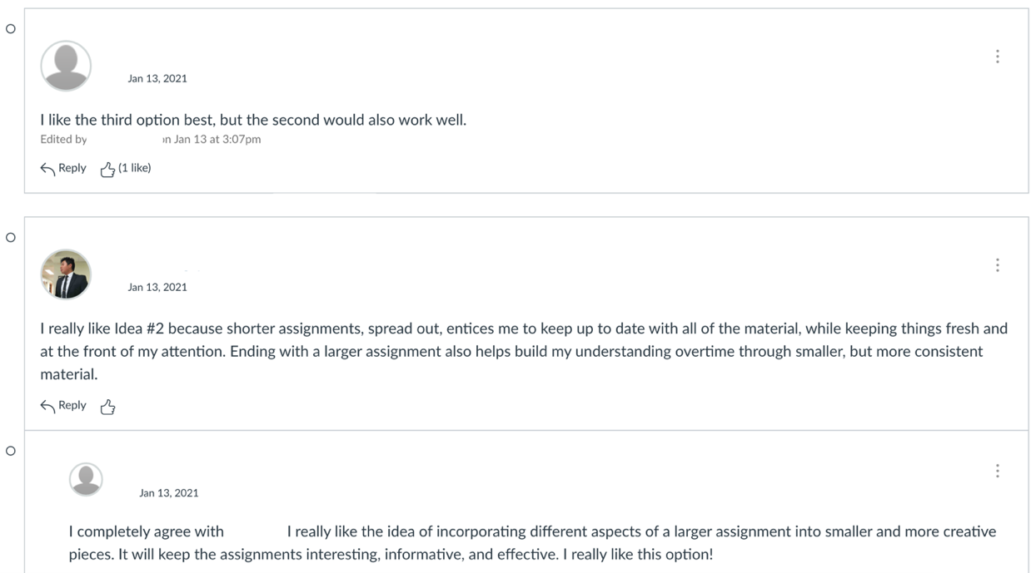
Figure 0-3. Screenshot of student responses to our discussion post.

Their discussion board feedback showed a fairly even split between options #2 and #3. Thus, in synthesizing their feedback, I opted for a compromise, which I’ll explain in the next section.

Outcomes
Ultimately, the students indicated they wanted to focus on analysis and research through assignments that built toward a final project. Further, there was a lot of interest in shorter, more contained analytical papers.

The final schedule of assignments we’ve agreed on is as follows:

- Assignment #1: Exploring an idea.
This 500 word assignment asks students to pick either a text or critical idea we’ve encountered in class and pair it with another text from the class. The goal here is to practice synthesizing the ideas they’re encountering while practicing short form essay writing; we’re focusing on structures that deviate from the “5 paragraph essay” they’re more familiar with. Working with texts we’ve already discussed also allows them to practice synthesizing secondary sources together in a lower-stakes format.

- Assignment #2: Close Reading & Research
To address the even split between multiple shortform papers & longer papers, I’m giving them an option to either turn in two 500 word papers or one 1000 word paper here. Regardless of whether they split it into two papers or not, they’ll be focusing on two goals:
- Identifying a relevant visual or literary work we haven’t discussed in class and performing a close reading connecting the work to the ideas we’ve discussed in class
- Researching a historical or theoretical concept we’ve encountered (examples given are queer theory approaches to gender/sexuality, mourning and AIDS, ACT UP’s history, etc) and advancing an analytical argument informed by that research

From there, they’ll develop a creative accompaniment that shares their research and analysis with a ‘public’ audience (their classmates). This can take any form – podcast, performance, comic, photoessay, etc; it gives them an opportunity to practice sharing academic ideas in a “non-academic” format.

- Assignment #3: Literature Review
Because research was widely agreed upon as a primary goal for them, a literature review felt like a natural fit. Due around the time I normally ask for final paper proposals (about a month out from the end of the course), this 600 word literature review gives them a space to do research into a topic they’re considering for their final project.

- Assignment #4: Final Project Proposal
This is simply an 150 word proposal for their final project, which will be research driven and address, in some way, one of the core questions of our course.

- Assignment #5: Final Project
At 1000 words, this is a shorter final project than I have assigned in previous classes, but because so much of the legwork will have been done throughout the semester in our other assignments, a shorter project focused on presenting an original analytical argument felt like a natural fit. I’ve deliberately used the word ‘project’ over ‘paper’ to make space for an unconventional approach, inspired by my colleague Cara Wieland’s “un-paper” assignment.
I’ve also left this deliberately open-ended so that we as a class can discuss together the formats it might take; depending on their feedback, I may revise or add more guidelines as needed. This, too, reflects the fact that by March they will likely have a much stronger sense of their interests and goals as writers.

Though this is the “final” schedule of assignments, I’ve made it clear we can make adjustments if the need arises.

Considerations for future application
The core process I used for collaborative assignment building is as follows:
- Set expectations: state in the syllabus that assignments will be designed collaboratively. State clearly the parameters for this (wordcounts, types of assignments, etc).
- Make an open-ended space for brainstorming: Google Jamboards is a great tool for this, but a collaborative document of any kind could work. During in-person lessons, I’d try having students write ideas on the whiteboard or write them down and hand them in. Writing ideas down as opposed to a verbal discussion is useful for students who may have anxiety or struggle to speak in group settings—it also helps to keep any one student from dominating the discussion as everyone is contributing.
- Synthesize this brainstorming: I chose to synthesize their ideas into a list and then spin off suggestions for assignments based off that list. I also made it clear those suggestions were open to revision if they felt I wasn’t honoring their initial ideas.
- Collect feedback on synthesis: I posted the synthesis in a discussion board and made time in class for them to read, process, and add their feedback. Making that time in class protects their and my time and labor by giving it set boundaries.
- Develop final assignment schedule and get approval: Following their feedback, I wrote out the final schedule of assignments and presented it to them in class. Again, I was sure to make space to let them tell me if they felt I misrepresented what they wanted, and made it clear we could revisit if needed.

My goal in designing writing assignments is to provide a space for students to experiment with their writing skills. Writing is not a natural, innate ability, and often, students have been trained to think about writing in a linear, defined approach that does not work for everyone. Rather than go in expecting students to “know” things like structure or grammar, I ask instead what they know they want to practice or learn. If they fall short, or if something they produce is unsuccessful, we can have a conversation about that, but I do not punish students for not knowing something I’m there to teach them in the first place.
Though I had my own ideas about what might work for this class, their suggestions took us in an entirely different direction from my original proposed outline. For example, the literature review as a way to move us into the final project came directly from their requests to focus on building research skills. They also helped me see more clearly how to build out the assignments to lead to their final project as a capstone, which is something I’ll definitely take into future classes whether I pre-build assignments or not.
There are limitations to this worth noting. One, because I am ultimately beholden to the policies of the university, we do have to meet the 6,000 word requirement. Two, ultimately I did make the final decisions on the format of the assignments, although I did so based on their suggestions. Three, everyone is adhered to the same schedule of assignments. These are not necessarily bad things, but they do reflect the top-down structure of higher ed classroom management.
In our class, spending the first week building assignments together enabled us to develop a sense of classroom community early on. The students have shown an investment in the course from the start which has extended to the quality of our discussions and of the work they’ve already turned in. This partially, likely, is because students often sign up for special topics courses out of an interest in the subject, rather than solely because they need the credit. However, I do argue that collaborative assignment building enables students to develop a strong early connection with the class, as they’re being given agency to shape the class to their needs.
I also argue that this process helps them see how each assignment enables them to develop their writing skills, because the goals of each assignment came directly from the skills they wanted to focus on learning. It’s absolutely true that connection can be made even when they aren’t directly involved in the assignment building—I’ve achieved that with collaborative rubric building, for example—however, by making assignment design visible and active to them, they can better understand how different assignment formats encourage different skill sets, and, hopefully, start to figure out what formats work best for them. To connect this back to disability justice and liberatory pedagogy: collaborative assignment building is one method to empower students’ to articulate their educational needs. By encouraging students to think critically about the assignments they’d like to do, they become more active agents in their education; this also helps them think critically about the structure of the writing classroom, which can then be connected to conversations about higher ed and power.
I will likely be adapting this collaborative process for future courses. Even in classes with a more rigid curriculum, soliciting student feedback and being in open dialogue with students about how the assignments are designed can help foster a more horizontal learning community. Ultimately, this experiment in collaborative assignment building has helped my pedagogy improve by letting me connect assignment design to the politics of my classroom and my pedagogical practice.

See remus jackson, F. Stewart-Taylor, and Cara Wieland, “Disability Justice and Mutual Aid Pedagogy or: How I Learned to Keep Worrying and Teach Later On,” Activist History, 2020, https://activisthistory.com/2020/03/31/disability-justice-and-mutual-aid-pedagogy-or-how-i-learned-to-keep-worrying-and-teach-later-on/

